Received: .../…/… Accepted: .../…/… Published:.../…/....
Title in English (Times New Roman; size-14;)
العـنـوان باللغة العربية (الخط: Arabic simplified، حجم الخط 14، تباعد أسطر 1,15)
Full name of the first author ¹, Full name of the second author ²
¹ Full affiliation (Country), professional e-mail of researcher
² Full affiliation (Country), professional e-mail of researcher
Abstract: (Do not exceed 150 words) (Times New Roman; Taille 12; Gras)
Enter your abstract here (an abstract is a brief, comprehensive summary of the contents of the article)
(Times New Roman; Taille 12)
Keywords: (Times New Roman; Taille 12; Gras)
(Times New Roman; Taille 12)
JEL Classification Codes: …, …, …
الملخص: ( 150 كلمة على الأكثر) (العنوان الخط: Arabic simplified، حجم الخط 12، غليظ)
ضع الملخص هنا (يتم الإشارة في الملخص إلى هدف البحث، والنتائج المتوصل إليها في فقرتين) (الخط: Arabic simplified، حجم الخط 12)
الكلمات المفتاحية: (العنوان الخط: Arabic simplified، حجم الخط 12، غليظ)
(الخط: Arabic simplified، حجم الخط 12)
تصنيفات JEL : ....، ....، .... (وضع ترميز JEL إجباري للدراسات الاقتصادية)
_____________

Corresponding author: Full name, e-mail: authorC@mail.com.

1.INTRODUCTION (Times New Roman; size-12; Gras)
The first subtitle opens with an introduction that presents the specific problem under study and describes the research strategy. (Times New Roman; size-12)
2.Title (Times New Roman; size-12; Gras)
2.1First Subtitle (Times New Roman; size-12; Gras)
Enter here the text of first subtitle. (Times New Roman; size-12)
2.2 Second Subtitle (Times New Roman; size-12; Gras)
Enter here the text of second subtitle. (Times New Roman; size-12)
3.Title
3.1First Subtitle
Enter here the text of first subtitle.
3.2 Second Subtitle
Enter here the text of second subtitle.

Table 1. Table title (this is an example of table 1)
Test 1 | Test 2 | Results 1 | Results 2 | Total Results
15.21 | 15.21 | 15.21 | 15.21 | 15.21
18.58 | 18.58 | 18.58 | 18.58 | 18.58
11.14 | 11.14 | 11.14 | 11.14 | 11.14
Source: author’s name, year, page
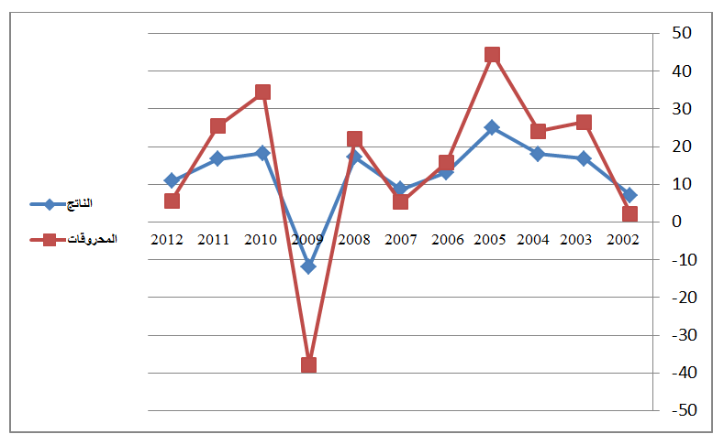
Fig.1. Figure title (this is an example of figure 1)

Source: author’s name, year, page

4. CONCLUSION (Times New Roman; size-12; Gras)
The conclusion of a research paper needs to summarize the content and purpose of the article. (Times New Roman; size-12)
References
References are important to the reader. Thus, quotes must be complete and correct.
Numbering all bibliographical references , and they should be in simplified font, size 11.referances are reffered to by putting the referance number without brackets.
5. Bibliography List :
(1) Author, "title of the article," magazine name, folder, number, and year.
Books:
(2) Author, title of the book, publisher, pages.
Forums:
(3) The author, "title of the article," name of the forum, place, year.

